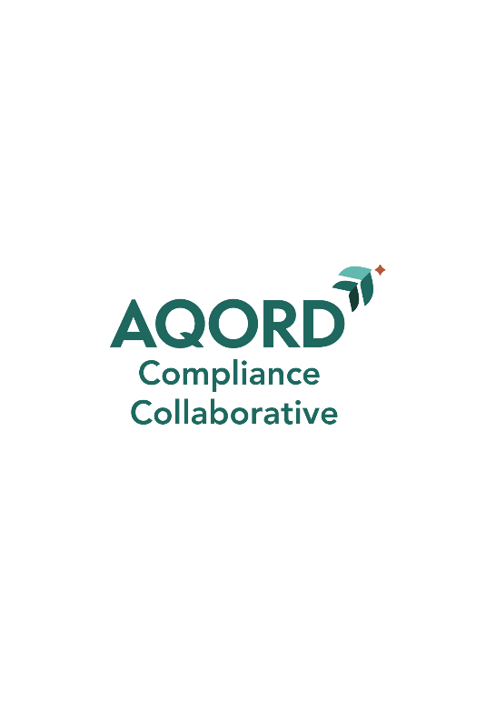

WELCOME
This toolkit is intended to assist new Board members in understanding the scope and purpose of a compliance program and to assist the new board member in understanding your role in our community’s compliance program.
YOUR ORGANIZATION NAME participates in the AQORD Compliance Program. Through a contractual arrangement, the AQORD Compliance Program provides the services of a compliance officer and compliance specialists. The AQORD Compliance Program provides ongoing support in the development, implementation and monitoring of our compliance program. In addition to ensuring that the organization remains up to date with regulatory changes and expectations, the program provides onsite monitoring audits and reviews on identified risk areas. The compliance program works through our employee, known as the Compliance Official, who serves as the primary compliance person, onsite at our organization. The Compliance Official is supported by the High-Level Compliance Official and a Compliance Committee. In addition, the AQORD Compliance Program provides support and ongoing monitoring of the Compliance Committee by reviewing compliance committee minutes and providing input to meeting agenda and content.
Please take the time to review this program. Contact “Your Executive Director’s name” or the Compliance Officer, Karla Dreisbach, at kdreisbach@aqord.org if you have any questions.

OUR COMPLIANCE STAFF
Compliance High-Level Official: fill in key information (name, email and phone #)
Compliance Official: fill in key information (name, email and phone #)

