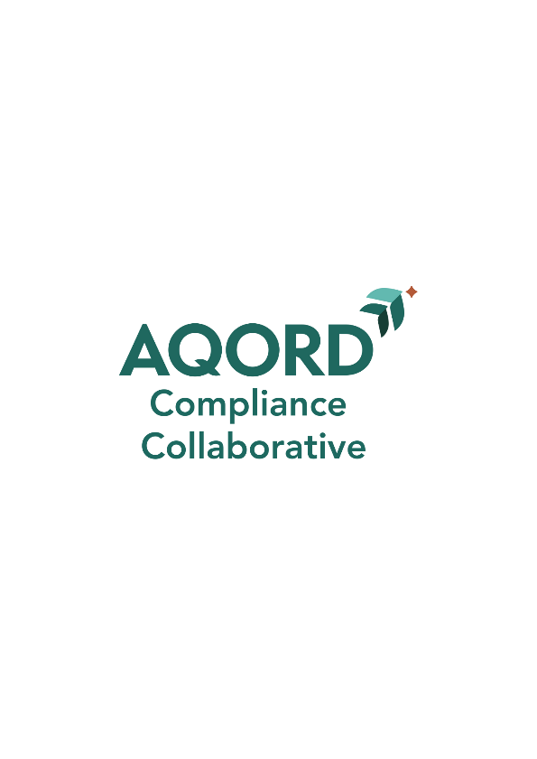

Compliance Program Orientation
for Board Members
(YOUR FACILITY NAME AND/OR LOGO HERE)

